Lab Report - Lab 3

Michael White - Section 3 - 421L

4/29/2021

For this lab, the purpose was to evaluate if the systems presented are equivalent, as claimed in Patent 7,493,601. This includes calculating the theoretical time constants for each system. After this, the experimental time constant values are obtained from the actual systems. These time constants can then be compared with the other systems. In addition to finding the time constants for comparison, the transfer functions for each system will also be compared. In completion of this lab, it was found that the electrical and thermal system were identical, but the transfer function of the water system differed from the electrical and thermal system.

The purpose behind this lab is to assure that the claims made in Patent 7,493,601 are valid. These claims mainly involve the included systems being equivalent, as would be evident in the derived transfer functions.

For the electrical system, a resistor of 4.7 kΩ and capacitor of 10 nF are connected to the wave generator and the voltage across the capacitor is measured at the oscilloscope. This data is outputted and analyzed via MATLAB.

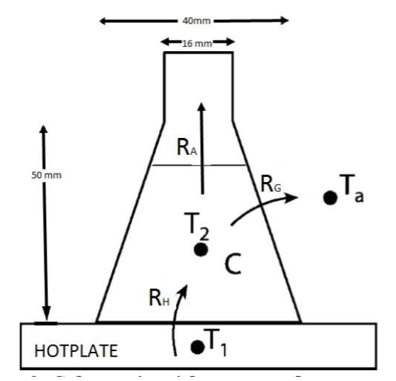

Figure 1. Thermal System in Lab [1]

For the thermal system, a thermistor is placed in a flask of water. The water is heated to 50 degrees Celsius via a constant temperature hot plate and the temperature at the thermistor is recorded over time. This data is again analyzed via MATLAB.

For the water system, a reservoir with a hole at the bottom is filled via a constant flow stream. The time at which the water level in the reservoir reaches certain heights is recorded. This data is then analyzed in MATLAB, including the fitting of a logarithmic equation.

MATLAB code was used entirely for the data analysis of this lab. Looking towards the results of the time constants which were obtained, the results were somewhat similar, with noticeable error on the thermal system. The following table of time constants, both theoretical and experimental, was obtained from MATLAB results and code, which will be included at the end of this report.

Table 1. Time Constants from All Present Systems

|  |  |  |  |
| --- | --- | --- | --- |
| **Time Constant (tau)** | **Electrical System** | **Water System** | **Thermal System** |
| Theoretical | 0.000047 | 239.8596 | 260.5925 |
| Experimental | 0.000050 | 201.22000 | 769 |

Looking at these results, the theoretical time constants are clearly fairly close to the experimental values, except for the thermal system. Though, it is somewhat expected that the thermal system is relatively high in error as there are a high number of assumptions. In other words, the theoretical value is highly idealized.

The following figures are pulled directly from the MATLAB code included below:

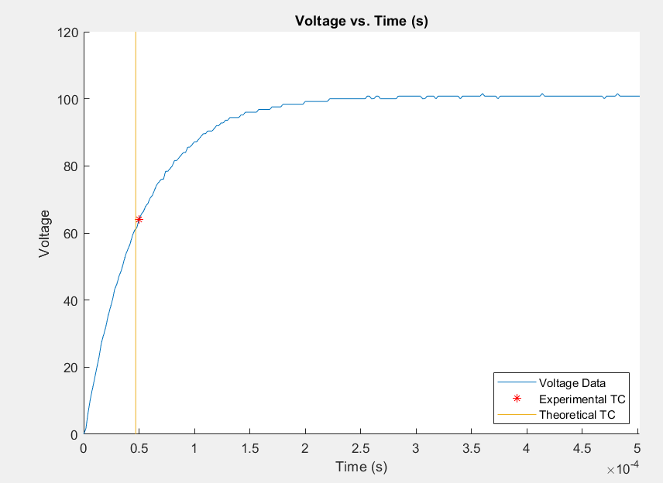

Figure 2. Plotted Data from Electrical System

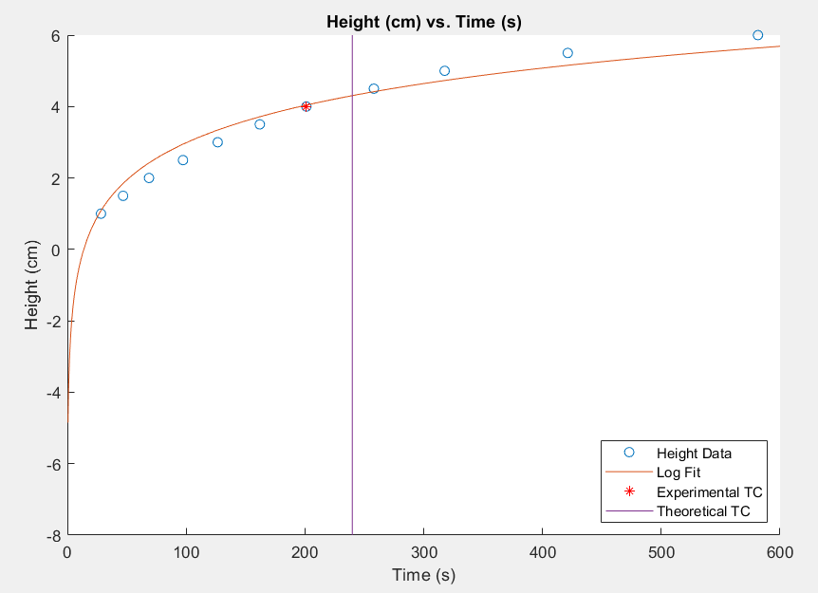

Figure 3. Plotted Data from Water System

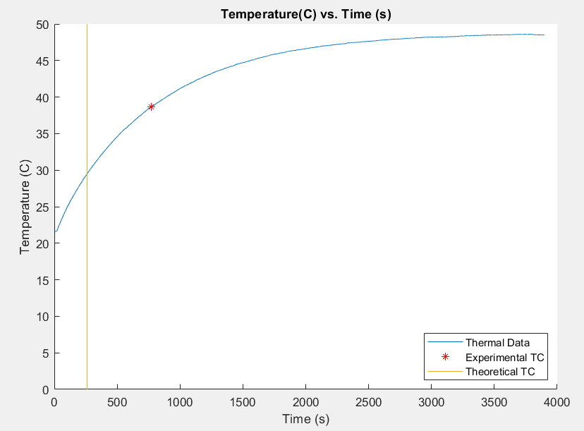

Figure 4. Plotted Data from Thermal System

Looking at these figures, the data looks very acceptable. The time constants are relatively accurate, except for the thermal system, which is obviously acting slower than the ideal scenario. This, again, likely arises from additional loss of heat which is not accounted for in the idealized calculations.

Hand calculations were also done for each of the systems to acquire the transfer functions. These hand calculations can be found below after the MATLAB code. The results are as follows:

Table 1. Transfer Functions from All Present Systems

|  |  |  |
| --- | --- | --- |
| **Electrical System** | **Water System** | **Thermal System** |
| $$G(s)=\frac{1}{RCs+1}$$ | $$G(s)=\frac{R/g}{RCs+1}$$ | $$G(s)=\frac{1}{RCs+1}$$ |

These transfer functions are all relatively similar, though the numerator in the transfer function of the water system is different. The value is however, still a constant, making the differences seen between the systems still fairly low. Again, the derivations for these transfer functions can be found below.

In conclusion, these systems are all extremely similar. However, the water system does not meet the equivalence check due to its transfer function being different from the other two systems. The errors present in this lab were relatively low, except for the thermal system. This error likely results from the difference in the idealized system used to calculate the theoretical value, which assumes relatively low heat loss in the system. In reality, it takes much longer for the water to heat up, which suggests that not all the heat loss of the system is being accounted for.

**REFERENCES**

[1] “First Order Dynamic System Analysis of Thermal System.” Iowa State University. 4 April 2021.